COMSATS University Islamabad, Islamabad Campus



Secure Software Design and Development
Lab Final

Threat Modelling and Risk Scoring

Student Names | Muhammad Awais , Muhammad Umair Nazir , Muhammad Umar
Registration Numbers | SP23-BCT-008 , SP23-BCT-038 , SP23-BCT-040
Submission Date | 12 June 2026
Submitted To | Mr Muhammad Ahmed Nawaz

Contents
Student Result Portal 3
STRIDE Analysis 3
Component 1 — Login / Auth Service 3
Component 2 — Result Viewing (Student) 3
Component 3 — Grade Upload (Teacher) 4
Component 4 — Admin Panel 4
Component 5 — Database (PostgreSQL) 5
Component 6 — Kafka Event Stream 5
PASTA Analysis 6
Stage 1 — Define Objectives 6
Stage 2 — Technical Scope 6
Stage 3 — Application Decomposition 6
Stage 4 — Threat Analysis 7
Stage 5 — Vulnerability Analysis 7
Stage 6 — Attack Modelling 7
Attack Tree 1 — Student Changes Own Grade 7
Attack Tree 2 — Mass Data Exfiltration 7
Attack Tree 3 — System Disruption 8
Stage 7 — Risk & Impact Analysis 8
MITRE ATT&CK Mapping 9
ATT&CK Navigator 9
Mapped Techniques (double click to open Heatmap) 9
Mitigations per Technique 10
Risk Matrix 10
Scoring Formula 10
Risk Matrix Table 11
Risk Summary 11
Top 3 Priority Mitigations 11

Student Result Portal

STRIDE Analysis

Component 1 — Login / Auth Service
STRIDE | Threat | Attack Example | Mitigation
Spoofing | Attacker impersonates student/teacher | Stolen JWT reused after logout | JWT blacklisting, short expiry (15 min)
Tampering | Modify JWT payload to escalate role | Change "role":"student" to "role":"admin" | JWT signed with RS256, verified server-side
Repudiation | User denies logging in from unknown location | No login audit trail | Log all logins with IP, timestamp, device
Info Disclosure | Login error reveals if email exists | "Email not found" vs "Wrong password" | Use generic error: "Invalid credentials"
DoS | Flood login endpoint | Credential stuffing, brute force | Rate limiting, account lockout after 5 attempts
Elevation | Bypass MFA to access teacher/admin account | MFA token reuse | TOTP with 30s window, single-use tokens

Component 2 — Result Viewing (Student)
STRIDE | Threat | Attack Example | Mitigation
Spoofing | Student pretends to be another student | Forged JWT with different student_id | Bind JWT claims to server-side session
Tampering | Intercept and modify result response | MITM attack on unencrypted connection | Enforce TLS 1.3, HSTS headers
Repudiation | Student denies viewing result | No access record kept | Audit log every result view
Info Disclosure | Student accesses another's results | Change studentId in API request (IDOR) | Enforce WHERE student_id = JWT.sub always
DoS | Spam result endpoint | Thousands of requests per second | Rate limiting per user per endpoint
Elevation | Student accesses teacher/admin views | Manipulate role in request header | RBAC enforced server-side only, never client

Component 3 — Grade Upload (Teacher)
STRIDE | Threat | Attack Example | Mitigation
Spoofing | Teacher uploads grades for another's course | Valid JWT but wrong course ID | ABAC: verify teacher→course assignment
Tampering | Inject malicious content in CSV | =CMD|'/C calc' in grade field | Strip formulas, validate each cell strictly
Repudiation | Teacher denies uploading wrong grades | No record of who uploaded what | Log teacher ID, courseID, timestamp, file hash
Info Disclosure | CSV contains all students' data exposed | Insecure file storage after upload | Delete CSV immediately after processing
DoS | Upload massive CSV file repeatedly | 1GB file floods server | File size limit (max 2MB), async processing
Elevation | Teacher approves own grade submission | Teacher calls approve endpoint directly | Approval restricted to Admin role only

Component 4 — Admin Panel
STRIDE | Threat | Attack Example | Mitigation
Spoofing | Attacker impersonates admin | Stolen admin session token | Step-up re-authentication for all critical actions
Tampering | Admin directly edits grade in DB | Bypasses audit trail via direct DB call | All changes through application layer only, DB not exposed
Repudiation | Admin denies creating rogue account | No log of admin actions | Immutable audit log for every admin action
Info Disclosure | Admin panel exposes all student PII | No data masking on list views | Mask sensitive fields (CNIC, DOB) in list views
DoS | Flood admin APIs with requests | Repeated expensive report generation | Rate limit admin endpoints, async report generation
Elevation | Teacher gains admin privileges | Exploits broken access control | Strict RBAC, roles never derived from user input

Component 5 — Database (PostgreSQL)
STRIDE | Threat | Attack Example | Mitigation
Spoofing | Service connects to fake DB | DNS spoofing redirects to attacker DB | Certificate pinning, mTLS for DB connections
Tampering | SQL Injection modifies grade records | 1; UPDATE results SET grade='A' | Parameterized queries only, no raw SQL
Repudiation | Grade changed with no record | Direct DB edit bypasses app logs | DB-level audit triggers + app-level logging
Info Disclosure | Full DB dumped via SQLi | UNION SELECT * FROM students | Least privilege DB accounts, WAF rules
DoS | Expensive query crashes DB | Nested SELECT with no timeout | Query timeout limits, connection pooling
Elevation | App DB user has superuser rights | Drops tables, creates admin accounts | Each service has its own minimal DB user

Component 6 — Kafka Event Stream
STRIDE | Threat | Attack Example | Mitigation
Spoofing | Rogue service publishes fake events | Fake ResultPublished event sent | mTLS + ACLs, only authorized services can publish
Tampering | Event payload modified in transit | Intercept and change studentId in event | TLS encryption, Schema Registry enforces structure
Repudiation | Service denies publishing bad event | No producer record kept | Kafka producer ID logged with every message
Info Disclosure | Sensitive data in event payload | Full student PII in Kafka message | Minimal data in events
DoS | Flood Kafka with junk events | Millions of fake events overwhelm consumers | Producer rate limits, ACLs per topic
Elevation | Consumer service gains producer rights | Notification service publishes grade events | Strict ACLs: each service has producer OR consumer role only

PASTA Analysis

Stage 1 — Define Objectives
Type | Objective
Business | Protect academic integrity, ensure student data privacy, maintain system availability
Security | Prevent grade tampering, unauthorized access, data breaches, and service disruption
Compliance | GDPR (student PII), FERPA (academic records), ISO 27001 (information security)

Stage 2 — Technical Scope
Component | Technology
Frontend | React.js
Backend Services | Node.js / Python (Auth, Result, Admin, Notification)
Database | PostgreSQL
Cache | Redis
Event Bus | Apache Kafka
Infrastructure | Docker + Kubernetes, Terraform, HashiCorp Vault
Exposure | Public internet via API Gateway (Nginx/Kong)

Stage 3 — Application Decomposition
Entry Points
- Login page (POST /api/auth/login)
- Grade upload (POST /api/grades/upload)
- Result view (GET /api/results/me)
- Password reset (POST /api/auth/reset-password)
Trust Levels
Level 0 → Anonymous (unauthenticated)
Level 1 → Student (read own data only)
Level 2 → Teacher (read/write assigned courses)
Level 3 → Admin (full access + audit)
Level 4 → System/Daemon (internal services only)

Stage 4 — Threat Analysis
Threat Source | Example Threat
External attacker | Credential stuffing on login, SQLi on APIs
Malicious student | IDOR to view others' results, JWT tampering
Rogue teacher | Upload grades for unauthorized course, modify after deadline
Compromised admin | Create fake accounts, approve fraudulent grades
Automated bots | Brute force login, flood endpoints with requests

Stage 5 — Vulnerability Analysis
Vulnerability | Location | Risk
IDOR | GET /api/results/{studentId} | Student views others' results
SQL Injection | Login, grade upload APIs | Data theft, grade manipulation
Broken Access Control | Grade approval endpoint | Teacher approves own grades
Missing Rate Limiting | Login endpoint | Brute force attack succeeds
JWT Not Invalidated | Logout flow | Token reuse after logout
Weak Password Reset | Reset token predictable | Account takeover

Stage 6 — Attack Modelling

Attack Tree 1 — Student Changes Own Grade
Goal: Change grade from F to A
├── Compromise teacher account (phishing / brute force)
├── Exploit IDOR on result update endpoint
├── SQLi on grade upload API
└── Social engineer admin to approve fake submission

Attack Tree 2 — Mass Data Exfiltration
Goal: Steal all student records
├── SQLi on any unparameterized query
├── Compromise admin account → export all reports
└── Direct DB access (if network policy missing)

Attack Tree 3 — System Disruption
Goal: Make portal unavailable during result day
├── DDoS login and result endpoints
├── Flood Kafka with junk events → consumer crash
└── Upload massive CSV files repeatedly → server crash

Stage 7 — Risk & Impact Analysis
Attack Scenario | Likelihood | Impact | Risk Level
IDOR — view another student's result | High | High | Critical
Grade tampering via SQLi | Medium | Critical | Critical
Admin account compromise | Low | Critical | Critical
Brute force on login | High | Medium | High
JWT token replay after logout | Medium | High | High
CSV formula injection | Low | Medium | Medium
DDoS on result publishing day | Medium | Medium | Medium
Fake Kafka event injection | Low | Medium | Medium

MITRE ATT&CK Mapping

ATT&CK Navigator
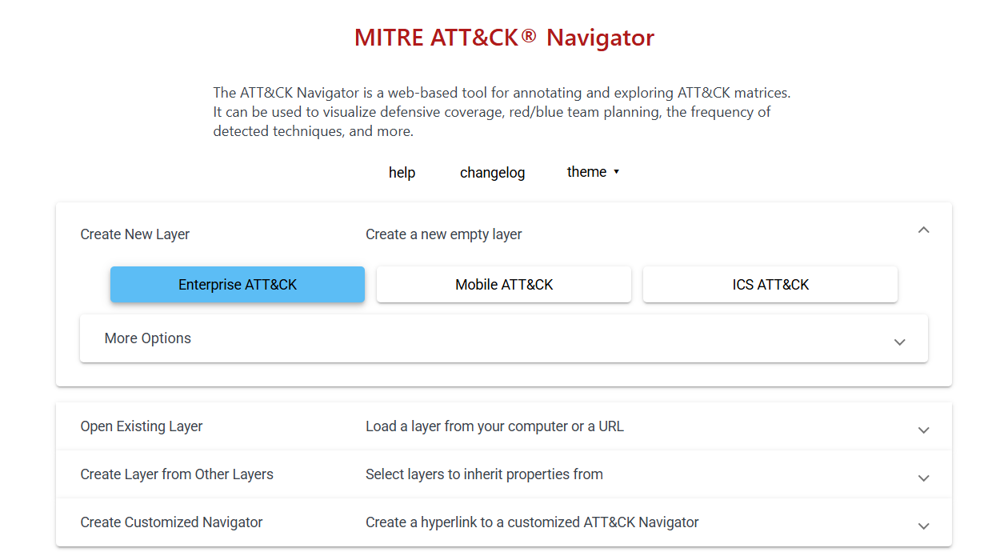

Mapped Techniques (double click to open Heatmap)
ATT&CK Technique | ID | How It Applies to Portal
Valid Accounts | T1078 | Stolen student/teacher credentials used to login
Brute Force | T1110 | Repeated login attempts on student/teacher accounts
Phishing | T1566 | Teacher tricked into revealing credentials via fake email
Exploit Public-Facing Application | T1190 | SQLi / XSS on login, grade upload, result APIs
Forge Web Credentials (JWT) | T1606.001 | JWT payload tampered to escalate role
IDOR / Broken Access Control | T1548 | Student accesses another student's result
Exfiltration Over Web Service | T1567 | Sending DB dump out via HTTP response
Account Manipulation | T1098 | Admin creates rogue teacher/admin accounts
Denial of Service | T1499 | Flooding login/result endpoints on result day
Man-in-the-Middle | T1557 | Intercepting unencrypted grade data in transit

Mitigations per Technique
Technique ID | Mitigation
T1078 | MFA, session invalidation on logout, JWT blacklisting
T1110 | Rate limiting, account lockout after 5 attempts
T1566 | Security awareness, email filtering, MFA
T1548 | RBAC/ABAC enforced server-side, never client-side
T1213 | Least privilege DB accounts, query restrictions
T1098 | Admin action re-authentication, immutable audit logs
T1070 | Tamper-evident logging, forward logs to QRadar instantly
T1499 | Rate limiting, WAF, auto-scaling
T1557 | TLS 1.3 everywhere, HSTS, mTLS between services

Risk Matrix

Scoring Formula
Risk Score = Likelihood (1-5) × Impact (1-5)

1-5 → Low
6-10 → Medium
11-15 → High
16-25 → Critical

Risk Matrix Table
Threat | Likelihood (1-5) | Impact (1-5) | Score | Risk Level
IDOR — student views another's result | 5 | 4 | 20 | Critical
SQL Injection on login/grade API | 3 | 5 | 15 | Critical
Admin account compromise | 2 | 5 | 10 | High
JWT token replay after logout | 3 | 4 | 12 | High
Brute force on login endpoint | 4 | 3 | 12 | High
Phishing attack on teacher/admin | 3 | 4 | 12 | High
DDoS on result publishing day | 3 | 3 | 9 | Medium
Fake Kafka event injection | 2 | 4 | 8 | Medium
Transcript forgery/download IDOR | 2 | 4 | 8 | Medium
Audit log tampering | 2 | 3 | 6 | Medium
Exposed DB credentials in source code | 2 | 5 | 10 | High
Session hijacking via Redis | 2 | 4 | 8 | Medium
XSS on result/profile page | 2 | 3 | 6 | Medium

Risk Summary
Risk Level | Count | Threats
Critical | 3 | IDOR, SQLi, CSV Injection
High | 6 | JWT replay, Brute force, Admin compromise, etc.
Medium | 6 | DDoS, XSS, Session hijacking, etc.
Low | 0 | —

Top 3 Priority Mitigations
Fix IDOR → Always query WHERE student_id = JWT.sub
Fix SQLi → Parameterized queries everywhere, no raw SQL
Fix CSV Injection → Strip formulas, validate every cell strictly

